Form I
ENTRY FORM FOR CIVIL SERVICES TOURNAMENT 2026-27
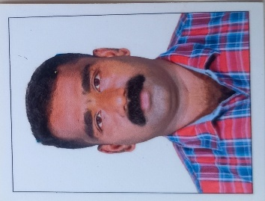
1. Full Name (In capital letters) : UNNIKRISHNAN.C
2. Age and Date of Birth : 43 Yrs 26.03.1983.
3 Gender : Male
4. Designation : Driver Grade I
5. Office Address : District Level ICDS Cell,
B 1 Block ,Civil Station Malappuram
6. "Designation & address of office Head : Programme Officer:
District Level ICDS Cell, B 1Block, Civil Station ,Malappuram
Office Email ID: Prgofficempm@gmail.com
7. Taluk/HQ Malappuram : HQ
8. Date of Entry in Service : 01/08/2011
9. Home Address : Cholayilthodi.House, Chathangottupuram. PO, Wandoor Via
,PIN 679328
Mob No:9447748220
10. Present pay and Scale of Pay : 41300/- (27900 - 63700)
11. Event in which participating : KABADDI ,HOCKEY,WRESTLING,YOGA
(separate entry forms for each events)
12. Details of previous achievements in Sports and Games :2021,2022 2024,2025 State Kabaddi Team member
13. Distance in Kms. from the place of duty to the venue of competition : 2 km

I declare that the information given above are correct.
Signature of Applicant
Certified that the particulars stated above by Sri UNNIKRISHNAN.C are correct.He/She is eligible to participate in the Civil Services Tournament 2026-27.

Signature and Designation of The Head of the (Seal) Office/Controlling Officer

NB: False information/suppression of information will lead to disqualification of the applicant to participate in the Tournament and no appeal will rest against this decision.

